**FASHION HUB**

**JOROGE RITAH MUMBI**

**This is a research project submitted to the School of Science, Engineering and Technology in partial fulfillment of the requirements for the award of Diploma in Information Technology, Kabarak University.**

**NOVEMBER, 2025.**

# COPYRIGHT

©2025

All rights reserved.

No part of this project may be reproduced, stored in any retrieval system or transmitted in any

Form or by any means, electronic, mechanical, photocopying and recording without prior written

intention of the author or Kabarak University on that.

Sign; Date; signature

# DECLARATION AND APPROVAL.

I declare that this work without any reasonable doubt has never been presented before to the Faculty of Information Technology

or any other institution. No part of this research document shall be duplicated without prior consent.

Signature ; Date;

Student: Njoroge Ritah Mumbi

Registration Number: DIT/N/1069/05/24

# RECOMMENDATION

This research project entitled Fashion Hub written by Njoroge Ritah Mumbi is presented to the School Of Science, Engineering and Technology, Kabarak University .I have reviewed this project

And recommend that it will be accepted in partial fulfillment of the requirements for the

Diploma in InformationTechnology.

Signature: Date:

Mr Elvine Saikwa

School of Science Engineering and Technology,

Kabarak University.

# DEDICATION

I dedicate this project, Fashion Hub, to my best friend, Jackson Murimi Kirimi. Your unique sense of style, talent in sewing, and constant encouragement have inspired me deeply. Thank you for showing me that fashion is just not about clothes, but about confidence, expression, and art.

# ABSTRACT

Fashion Hub is a digital platform that connects upcoming fashion designers with established professionals. It allows small designers to upload and display their creative works, providing them with an opportunity to gain visibility and recognition. The platform promotes creativity, inclusivity, and mentorship by offering opportunities and collaboration within the fashion industry.

**Keywords:** *Fashion, designers*

**TABLE OF CONTENTS**

COPYRIGHT 2

DECLARATION AND APPROVAL. 3

RECOMMENDATION 4

DEDICATION 5

ABSTRACT 6

List of Tables 10

List of Figures 10

CHAPTER ONE 11

INTRODUCTION 11

1.1 Background 11

1.2Problem Statement 13

1.3 Purpose of the study 13

1.4 General objective 13

1.4.1 Specific objectives 14

1.5 Research questions 14

1.6 Significance of the study 14

1.7 Scope of the study 15

1.8 Limitations of the study 15

1.9 Assumptions of the study 16

CHAPTER TWO 17

LITERATURE REVIEW 17

2.0 Introduction 17

2.1 The role of Technology in Fashion 17

2.2 Fashion in Kenya 17

2.3 Challenges Facing Upcoming designers 18

2.4 Existing Platforms And Their Limitations 18

2.5 Fashion Education And Mentorship 18

2.6 Conceptual Framework 19

2.7 Summary of the literature Review 19

CHAPTER THREE 20

RESEARCH METHODOLOGY 20

3.0 Introduction 20

3.1 System Development Methodology 20

3.1.1 Requirement analysis 21

3.1.2 Design Phase 21

3.1.3 Development Phase 22

3.1.4 Testing Phase 22

3.1.5 Maintenance and Feedback 23

3.2 Justification of Methodology 23

3.3 Functional Requirements 23

3.7 Summary 24

CHAPTER FOUR 25

SYSTEM ANALYSIS, AND IMPLEMENTATION 25

4,4 Output Design 30

4.5 System Implementation 32

4.6 Testing and results 32

4.7Summary. 33

CHAPTER FIVE 33

SUMMARY, CONCLUSION AND RECOMMENDATIONS. 33

5.0 Introduction 33

5.1 Summary 33

5.2 Conclusion 34

5.3 Recommendations 34

5.4 Future work. 34

# List of Tables

Table 1 list of tools used 12

Table 2: list of tests 20

# List of Figures

Figure 1 SystemArchitecture 13

Figure 2Data Flow Diagram (DFD)- Level 0 14

Figure 3Data Flow Diagram (DFD)- Level 1 15

Figure 4 User Registration Page 16

Figure 5Upload Page Design 17

Figure 6 Output Design 18

Figure 7Student Dashboard 19

Figure 8Teeacher Dashboard 19

# CHAPTER ONE

# INTRODUCTION

## Background

The fashion industry is one of the most dynamic creative fields in the world, continuously shaped by innovation, self-expression, and diversity. Yet many upcoming designers face challenges in getting their work recognized due to limited exposure, mentorship, and resources. Fashion Hub was created to bridge this gap –a digital platform designed to connect small upcoming designers with established fashion professionals like Melina Gold a popular Kenyan fashion designer who started independently, has unique aesthetic, and is connecting with clients and fashion houses like Sarai Afrique Fashion House.

As Giorgio Armani once said “*The difference between style and fashion is quality.*” This idea forms one of the pillars of Fashion Hub. The platform allows small scale and independent designers – including those specializing in diverse crafts such as crochet, beadwork, tailoring, and sustainable fashion – to upload and showcase their creative projects. By doing so, they gain access to a wider audience, including high end designers who may offer apprenticeship, or collaboration opportunities.

In addition to showcasing designs, Fashion Hub features a blog section where users can share articles, fashion tips, and creative insights, this encourages knowledge exchange, community engagement, and awareness of current fashion trends as well as nurturing confidence and storytelling through fashion. The inclusion of blogs help users express themselves fostering authenticity and personal growth.

Overall, Fashion Hub aims to bridge the gap between rising talent and professional opportunities in the fashion industry. It promotes inclusivity, creativity, and innovation by creating a supportive environment where every designer- regardless of background, style, or medium- can be seen , inspired, and empowered to succeed.

The platform distinguishes between two users:

1. Teachers: Fashion educators and professionals who create structured blog posts (educational content) and social posts (discussions)
2. Students: Learners who consume content, engage through interactions, and track their learning progress through achievements and statistics

Key features include:’

1. - Dual content system (Blog posts for formal education, Social posts for discussions)
2. - Interactive engagement system (likes, saves, comments)
3. - Comprehensive statistics and achievement tracking
4. - Responsive design for all devices
5. - Secure authentication and user management

## 1.2Problem Statement

The fashion industry in Kenya and beyond is rich in creativity but often lacks platforms that bridge that gap between emerging designers and already established designers. Many talented individuals, especially those working in niche areas such as crochet, and beadwork, struggle to gain recognition due to limited exposure, lack of professional networks, and minimal access to apprenticeship opportunities.

Traditional fashion houses and institutions primarily focus on already recognized designers, leaving upcoming creators with few chances to showcase their work or build meaningful industry connections. As a result, many promising designers remain unseen and unacknowledged, stunting the growth of local fashion talent.

There is therefore a need for a digital platform, that promotes inclusivity and provides equal opportunities for all designers to display their work, share ideas through blogs, and connect with potential mentors or collaborators. Fashion Hub seeks to solve this problem by offering a centralized space for visibility, interaction, and empowerment within the fashion industry.

## Purpose of the study

The The purpose of this study is to demonstrate how a specialized digital platform can enhance fashion education through technology-enabled learning, community engagement, and progress tracking systems.

## 1.4 General objective

To develop a comprehensive digital platform that facilitates fashion education through teacher-student collaboration, interactive content, and progress tracking.

## 1.4.1 Specific objectives

1. Create a dual-role system distinguishing between teachers (content creators) and students (learners)
2. Implement an interactive content system supporting both educational blogs and social discussions
3. Develop engagement features including likes, saves, comments, and view tracking
4. Design comprehensive statistics and achievement systems for both user roles
5. Ensure platform accessibility through responsive web design

## 1.5 Research questions

1. How can digital platforms enhance teacher-student collaboration in fashion education?
2. What features are essential for engaging fashion education in a digital environment?
3. How can achievement systems motivate continued learning in fashion education?
4. What technical architecture best supports a scalable fashion education platform?

## 1.6 Significance of the study

This study is significant because it addresses the growing need for specialized digital learning platforms in creative fields. Fashion Hub provides:

1. Accessible fashion education beyond institutional boundaries
2. Tools for fashion professionals to share knowledge broadly
3. Motivation systems through achievements and progress tracking
4. Community building through interactive features
5. A model for specialized educational platforms in other creative fields

## 1.7 Scope of the study

This project focuses on developing a web-based fashion education platform with the following scope:

1. User management with teacher/student roles
2. Content creation and management system
3. Interactive engagement features
4. Statistics and achievement tracking
5. Responsive web interface
6. Secure authentication system

## 1.8 Limitations of the study

1. Platform performance dependent on user internet connectivity
2. Initial user adoption may require digital literacy development
3. Content quality dependent on participating educators
4. Limited to web platform (no native mobile application initially)

## 1.9 Assumptions of the study

1. Fashion educators are willing to share knowledge digitally
2. Students are motivated by achievement and progress tracking systems
3. Digital platforms can effectively supplement traditional fashion education
4. Users have basic digital literacy for platform interaction

# CHAPTER TWO

# LITERATURE REVIEW

## 2.0 Introduction

This chapter explores existing ideas , studies, and tools related to fashion platforms, creativity, and digital exposure. It highlights how designers around the world and in Kenya have been using technology to grow, the challenges they face, and how Fashion Hub aims to fill the gaps left behind by current systems.

## 2.1 The role of Technology in Fashion

The fashion industry has entered a new era where technology plays a huge role in how creativity is shared. From social media platforms like Instagram and Pinterest to digital portfolios and online stores, fashion has moved beyond the runway. Designers can now connect with audiences and clients from anywhere in the world.

According to a report by Business of Fashion (2023), more than 70% of emerging designers use digital tools to showcase their work. However, many of these tools focus mainly on marketing or sales- not mentorship or skill growth. That is where Fashion Hub stands out- its not just about posting clothes; its about learning, connecting, and building a creative journey.

## 2.2 Fashion in Kenya

Kenya̛ s fashion industry is full of potential. Over the last decade, local designers have started to make global impressions- from Nairobi Fashion Week to online brands like Melina Gold Collective and Sarah Nkonge̛ s Sarai Afrique Fashion House. These designers blend African culture, sustainability, and innovation into their work.

Despite the progress, many young designers still struggle to be seen. Most rely on social media platforms that are often overcrowded, making it hard for fresh talent to stand out. Additionally, mentorship opportunities are rare and usually limited to established circles. Fashion Hub aims to change this by creating an inclusive digital space designed specifically for fashion growth- where a designer with a crochet piece has the same chance to shine as one with a couture gown.

## 2.3 Challenges Facing Upcoming designers

Upcoming designers face several common challenges:

1. Limited exposure: Many young designers create impressive work but have no platform to showcase it professionally.
2. Lack of mentorship: ̛̛Without guidance from experienced designers, it̛ s difficult for newcomers to grow their craft or understand the business side of fashion.
3. Financial barriers: Starting a fashion career often requires expensive materials, equipment, and marketing- things most upcoming designers can̛ t afford.
4. Digital exclusion: Some creatives lack access to the right tools or digital literacy to build an online presence.

These challenges highlight the need for a platform that not only displays creativity but also connects, teaches, and uplifts-the core mission of Fashion Hub.

## 2.4 Existing Platforms an their Limitations

There are already digital spaces where designers can share their work like Instagram, Behance, or Shopify- but these platforms don’t focus on building mentorship or young talent with established designers. They also lack categories for diverse crafts like crochet, beadwork, and handmade fashion that many Kenyan designers specialize in.

In contrast, Fashion Hub combines networking, learning, and showcasing in one space. It focuses on authentic growth-not just likes and followers. The platform promotes mentorship, diversity, and collaboration- things social media rarely guarantees.

## 2.5 Fashion Education And Mentorship

Mentorship is a vital part in a designer̛ s journey. Learning from those who have already walked the path can make a huge difference. According to Fashion Revolution(2022), mentorship and collaboration are among the top three factors that help new designers succeed in their careers.

Fashion Hub integrates this by encouraging high-end designers and fashion houses to discover and guide young creatives through apprenticeship programs. This approach makes mentorship accessible to anyone with talent and fashion-regardless of where they come from or what resources they have.

## 2.6 Conceptual Framework

The conceptual framework of Fashion Hub revolves around three main components:

1. Showcasing Creativity: Designers upload their projects and build portfolios.
2. Learning and Connections: Through blogs, mentorship, and discussions, designers share experiences and gain knowledge.
3. Opportunity growth: Established professionals can vie portfolios, offer collaborations, or mentorship opportunities.

These components interact to form a cycle- creativity leads to exposure, exposure leads to opportunity, and opportunity inspires new creativity.

2.7 Summary of the literature Review

From this review it is clear that while the fashion industry has embraced technology, there is still a gap in platforms that focus on supporting new designers through mentorship and inclusivity. Fashion Hub steps in to fill that gap-not just as a website, but as a community built on passion, creativity, and opportunity.

# CHAPTER THREE

# RESEARCH METHODOLOGY

## 3.0 Introduction

This chapter explains how Fashion Hub system was planned, designed, and developed. It outlined the process used to build the platform, the tools and technologies applied, and how data was collected and tested. The goal was to create a digital space that feels user-friendly, stylish, and empowering to upcoming designers.

## 3.1 System Development Methodology

The project was developed using the Agile Methodology. This approach was chosen because it allows flexibility, teamwork, and constant improvement- which mirrors how creativity works in the fashion world. Just like design, technology evolves through collaboration and revision. Agile made it possible to build Fashion Hub step by step, testing and refining each stage to ensure the final product met both user needs and design goals.

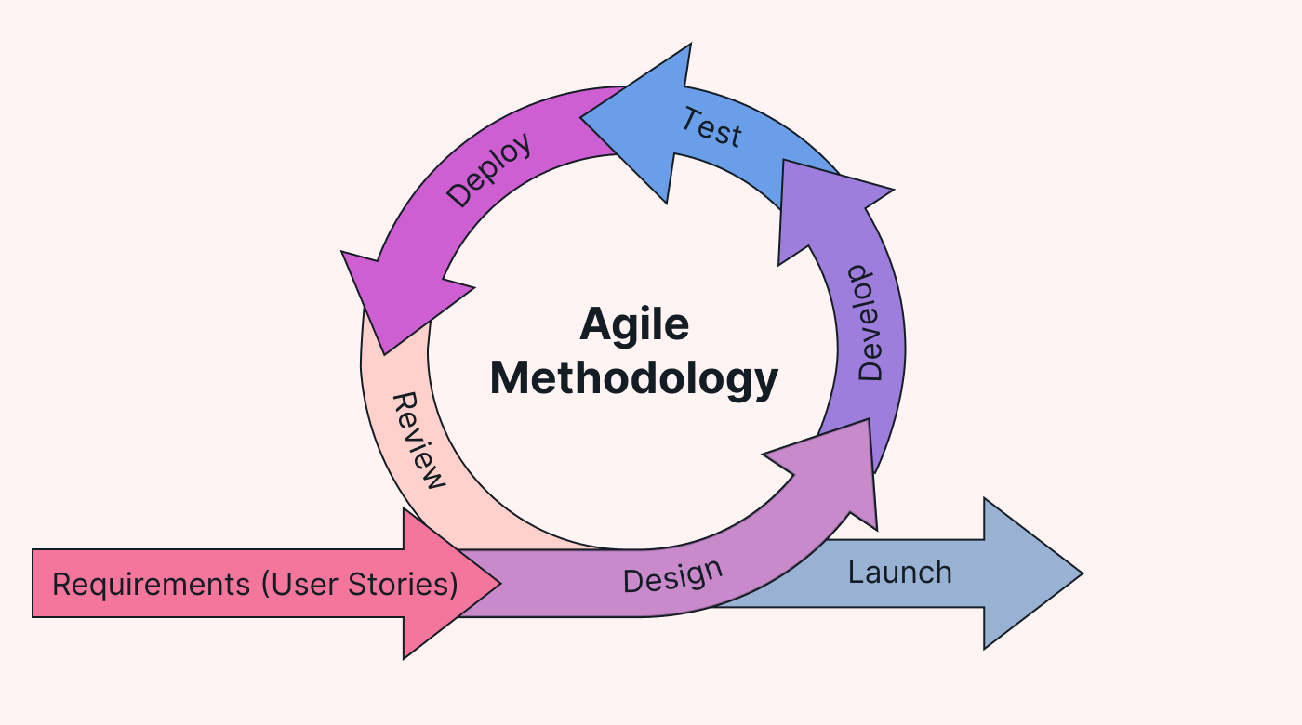

Fig 3.1 agile methodology

### **3.1.1 Requirement analysis**

The first step involved identifying what users needed the most. Information was gathered from observing how fashion designers currently share their work online and through conversation with students and creatives in the fashion community.

From this research, the following needs were identified:

1. A clean, simple interface where designers can showcase their fashion projects.
2. A blog space for sharing creative ideas, fashion insights, and stories.
3. A platform where established designers can view upcoming talent.
4. A secure system for registration, login, and data storage.
5. A responsive website that works smoothly on both mobile and desktop devices.

These insights helped define the platform̛ s functional and non-functional requirements.

Fig 3.2 Requirement gathering process

Observation n̛ Interviews n̛ Research n̛ Requirements Identified.

### **3.1.2 Design Phase**

The design process was entered around creativity and simplicity-much like fashion itself. The interface was designed using HTML, CSS, and JavaScript to achieve clean, elegant, modern aesthetic.

Wireframes were first sketched to visualize how users would interact with the site- from browsing portfolios to reading blogs. The focus was to create a platform that felt like an online fashion gallery, where every designer̛̛s work could stand out and be celebrated.

### **3.1.3 Development Phase**

The development of Fashion Hub was done using:

1. HTML- Building the backbone of the web pages.
2. CSS for styling- Making the interface visually appealing and professional.
3. JavaScript-Creating responsive features, smooth navigation, and dynamic components.
4. Node.js for backend functionality-Handling requests, managing server- side logic, and ensuring performance.
5. MySQL for database management- Securing storing user profiles, uploaded designs, and blog content

Node.js allowed the system to be efficient and scalable, while JavaScript enhanced interactivity, making Fashion Hub lively and user friendly.

### **3.1.4 Testing Phase**

Testing was carried out at every stage to ensure everything worked as expected. The main goal was to confirm that users could easily interact with the platform without technical issues.

The following tests were conducted:

1. Login test: Confirmed that only registered users could access the system.
2. Upload test: Checked that the designers could upload images of their work successfully .
3. Blog test: Ensured users could post and fashion- related articles.
4. Performance test: Verified that pages loaded quickly and ran smoothly on different devices.

Feedback was collected from a few creative users who tested the platform and suggested improovements, which were then applied in the next development cycle.

### **3.1.5 Maintenance and Feedback**

After development and testing, the maintenance phase focused on improving performance, fixing small bugs, and adding requested features. Continuous user feedback helped refine the system and keep it practical and relevant for real world use.

## 3.2 Justification of Methodology

The agile methodology was ideal for this project because of its flexibility and focus on user feedback. It allowed for creative input, teamwork, and quick adaptation-qualities that mirror the fashion industry itself. This approach helped ensure that Fashion Hub was not only functionable but also appealing, interactive, and easy to use.

## 3.3 Functional Requirements

These define what a system should do:

1. Allow users to create accounts and log in successfully and securely.
2. Enable designers to upload and manage their fashion projects.
3. Provide blog section for sharing ideas and stories.
4. Allow established designers to view portfolios and contact upcoming talent.
5. Display an organized dashboard for user activities and updates.

## 3.4 Non- Functional Requirements

These describe how the system should perform;

1. Usability: The platform should be simple and intuitive.
2. Performance: Pages should load quickly and respond efficiently.
3. Security: User accounts and data must be well protected.
4. Reliability: The platform stable and error- free during use.

Table 1 list of tools used

|  |  |
| --- | --- |
| **TOOL/TECHNOLOGY** | **PURPOSE** |
| HTML | Building the structure of web pages |
| CSS | Styling and enhancing visual design |
| JAVASCRIPT | Adding interactivity and responsive behavior |
| NODE.JS | Managing the server- side logic and system operations |
| MYSQL | Storing data such as user information, projects, and blogs |

## 3.6 Data Collection Methods

Primary Data:

Information was collected from upcoming fashion designers, stylists, and students through interviews and casual conversations. They shared challenges they face in getting recognition and what features they $\text{̛}$ d want in a platform like Fashion Hub.

Secondary Data:

Additional information came from online sources, articles, and fashion websites that discuss digital transformation in the fashion industry. This included insights into how technology is helping creatives grow in Kenya and across the world.

## 3.7 Summary

This chapter outlined how Fashion Hub was developed- from planning and design to testing and feedback. Using HTML,CSS, JavaScript, Node.js, and MySQL, the system was built to be practical, interactive, and user- friendly, guided by the agile methodology, every stage was improved through collaboration and creativity. The result is a platform that gives designers not just visibility but a voice helping them connect, grow, and belong in the fashion world.

# CHAPTER FOUR

# SYSTEM ANALYSIS, AND IMPLEMENTATION

## 4.0 Introduction

This chapter explains how the Fashion Hub system was analyzed, designed, and implemented. It provides detailed view of the systems structure, how data flows within it, and how users interact with is main features. It also describes the testing and the results that confirmed the system works efficiently. The goal was to make fashion hub as simple, beautiful, and reliable as possible for upcoming designers.

## 4.1 System analysis

The system analysis phase focused on understanding what the platform needed to achieve and how it would solve the problem of limited exposure for upcoming designers. It involved breaking down the systems requirements, identifying user roles, and defining how each part of the platform would function.

## 4.2 System Design

The system was designed to have a smooth flow between users, the interface, and the database. Its layout focuses on simplicity and accessibility ensuring users can easily upload their fashion projects, read blogs, and interact with other designers

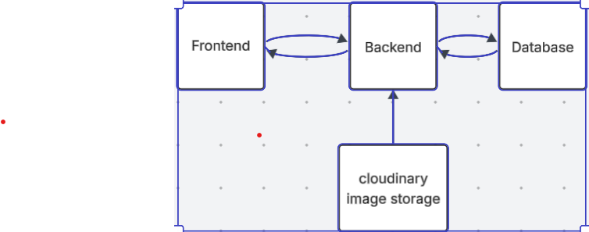

Figure 1 SystemArchitecture

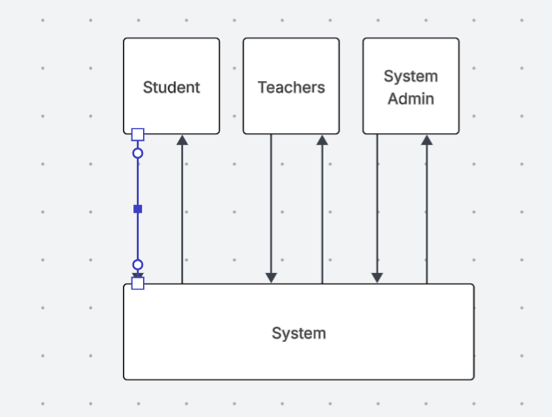

Figure 2Data Flow Diagram (DFD)- Level 0

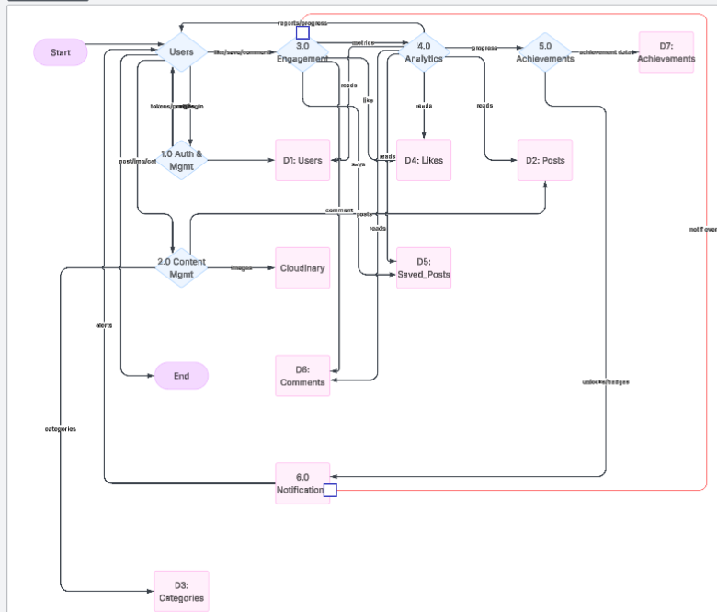

Figure 3Data Flow Diagram (DFD)- Level 1

## 4.3 Input Design

The input design stage focused on making the system easy to use and appealing. Designers interact with simple forms and upload buttons to share their fashion projects and write blog posts. The input forms are designed to be clean, with clear labels and minimal clutter just like a well- fitted outfit.

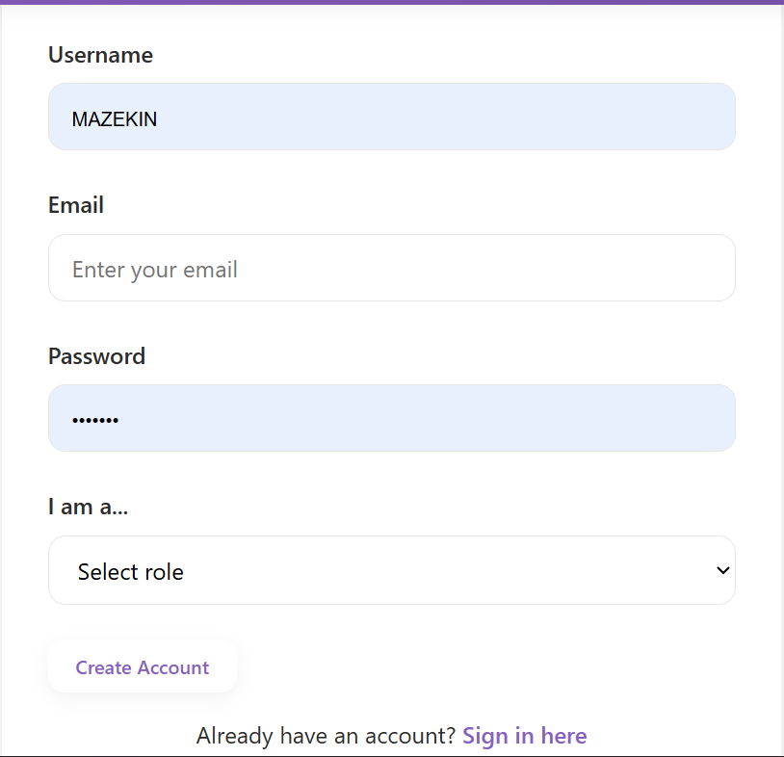

Figure 4 User Registration Page

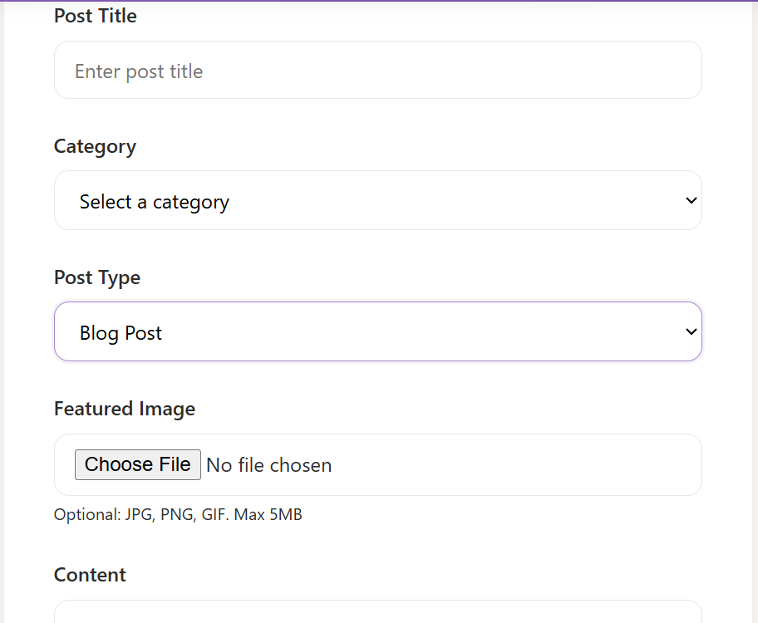

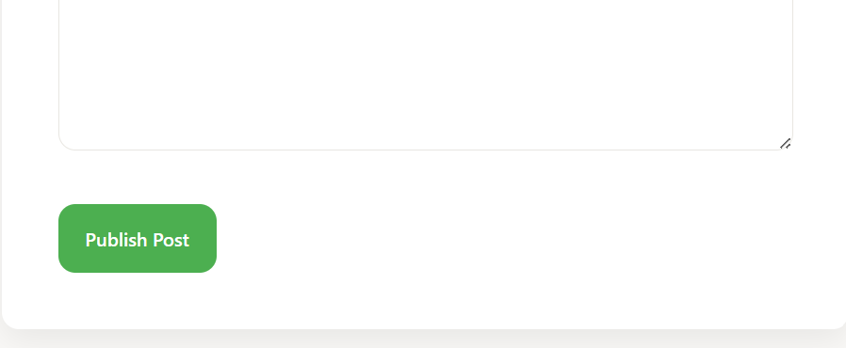

Figure 5Upload Page Design

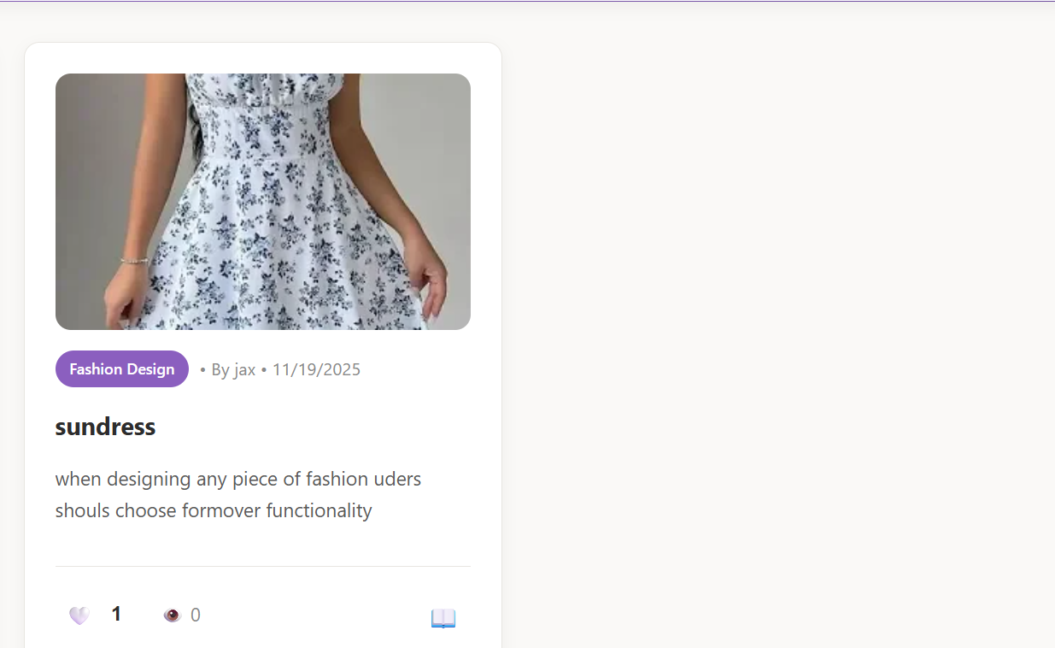

Figure 6 Output Design

## 4,4 Output Design

The output design shows what users see after interacting with the platform. For example, uploaded designs appear in a gallery style layout and blogs display in a readable, elegant format. The system dashboard displays key information like recent uploads, new posts, and user activity.

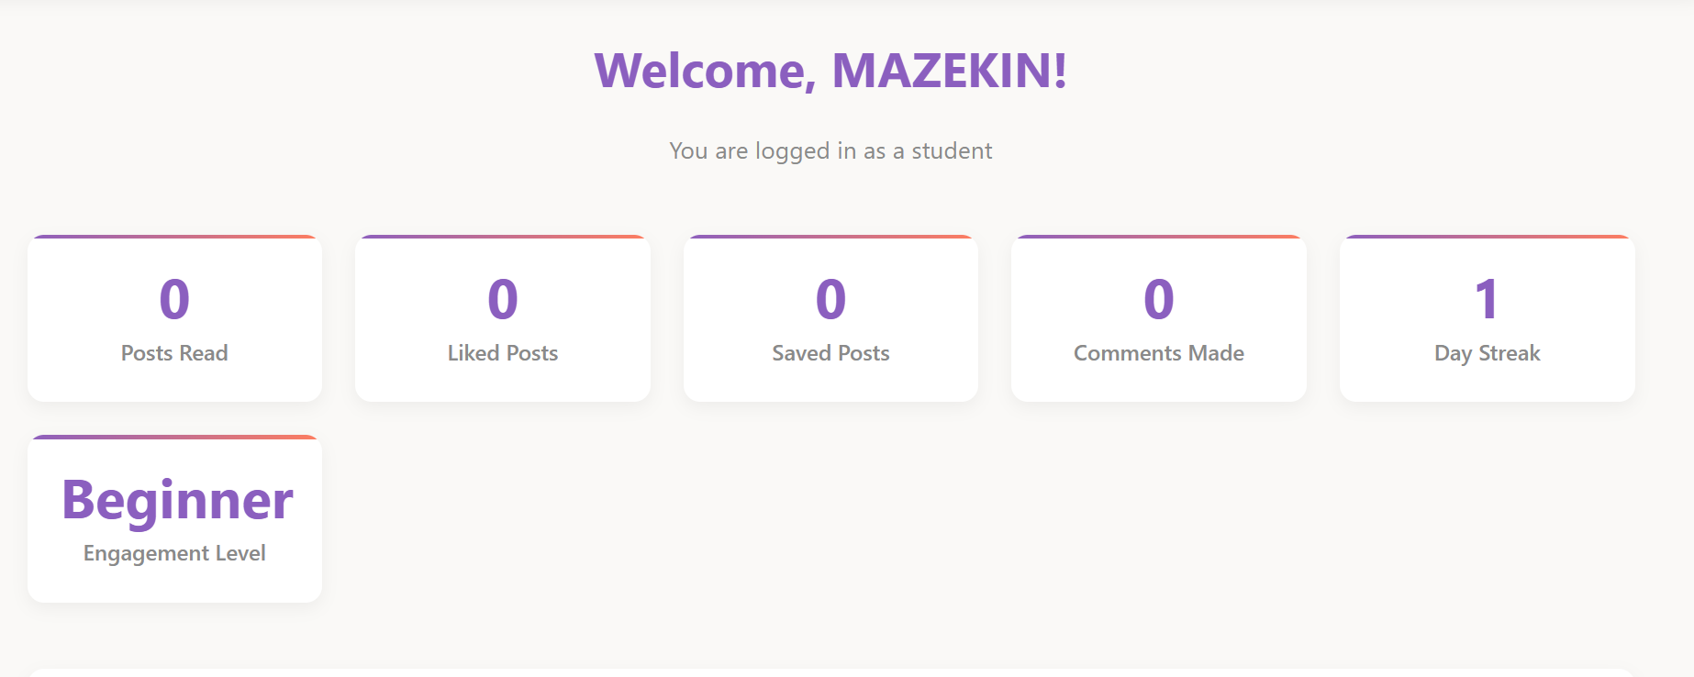

Figure 7Student Dashboard

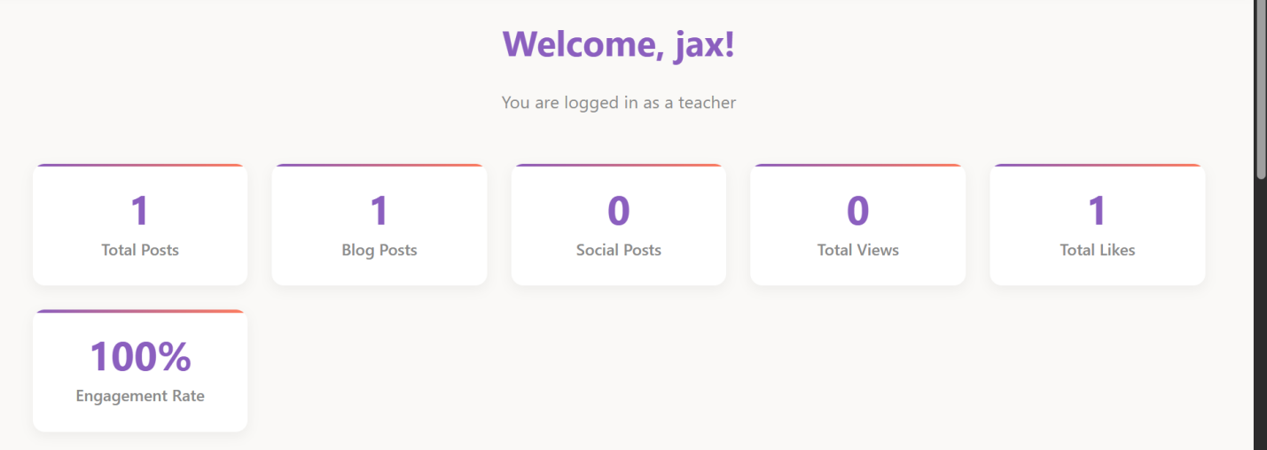

Figure 8Teacher Dashboard

## 4.5 System Implementation

Implementation involved combining all the design and development stages into a working product. The system was coded using HTML, CSS, JavaScript, Node.js, and MySQL.

Data was stored in the MySQL database, while Node.js handled server communication and user authentication. The front end was made interactive using JavaScript to ensure smooth transitions and responsiveness on different designs.

## 4.6 Testing and results

Testing was done to ensure that the platform worked as expected and provided a smooth experience.

Some of the main tests included:

|  |  |  |  |
| --- | --- | --- | --- |
| **MODULE** | **TEST CONDUCTED** | **EXPECTED RESULTS** | **OUTCOME** |
| User Login | Very correct credentials | User logs in successfully | Pass |
| Upload Feature | Upload a fashion design | Image and info displayed on dashboard | Pass |
| Blog Module | Create a new blog post | Posts appears under blog list | Pass |
| Performance | Load under 3 seconds | Pages load successfully | Pass |

Table 2: list of tests

## 4.7Summary.

This chapter covered analysis, design, and implementation of Fashion Hub. It illustrated how the system components interact and how users can access different features such as uploading designs, writing blogs, and connecting with mentors. With all parts integrated, Fashion Hub functions as an online creative space that connects talent, builds community, and promotes growth in Kenya̛ s fashion industry.

# CHAPTER FIVE

# SUMMARY, CONCLUSION AND RECOMMENDATIONS.

## 5.0 Introduction

This chapter summarizes the entire Fashion Hub project, presents the main conclusions drawn from its development, and recommendations for future improvements.

## 5.1 Summary

The Fashion Hub project was created to give upcoming designers a platform to showcase their creativity, connect with professionals, and grow in the fashion industry. The system was designed using HTML, CSS, JavaScript, Noe.js, and MySQL, guided by the agile methodology for flexibility and collaboration.

Through continuous testing and feedback, the platform evolved into a user-

friendly space where designers can upload their projects, write blogs, and interact with mentors. Fashion Hub successfully bridges the gap between emerging and established designers, encouraging creativity and community .

## 5.2 Conclusion

The study concluded that technology can play a powerful role in supporting talent. Fashion Hub not only provides visibility but also inspires learning and connection among designers. It stands as a creative and inclusive space for Kenyan and global fashion communities proving that when creativity meets technology, opportunities multiply.

## 5.3 Recommendations

1. Introduce a mobile app version for easier access.

2. Add a chat or mentorship feature to connect designers directly with professionals.

3. Incorporate AI-based recommendations to match designers with potential mentors or fashion houses.

4.Continously collect user feedback to keep improving the platform̛ s design and performance.

## 5.4 Future work.

Future development could include integration online stores, fashion competitions, and digital portfolios. These features would rather empower designers to grow their personal brands and expand their reach globally.